**SQL**

**ASSIGNMENT 4**

**Assignment 4 : Create Stored procedure in Northwind database to insert or update a**

**record in a table**

**1. Create a stored procedure in the Northwind database that will calculate the average**

**value of Freight for a specified customer.Then, a business rule will be added that will**

**be triggered before every Update and Insert command in the Orders controller,and**

**will use the stored procedure to verify that the Freight does not exceed the average**

**freight. If it does, a message will be displayed and the command will be cancelled.**

**Average value of Freight -**

USE [Northwind]

GO

/****** Object: StoredProcedure [dbo].[sp_avg_freight] Script Date: 08-02-2023 17:30:26 ******/

SET ANSI_NULLS ON

GO

SET QUOTED_IDENTIFIER ON

GO

ALTER PROCEDURE [dbo].[sp_avg_freight] (@customerID INT, @avgval float output)

AS

BEGIN

-- Calculate the average Freight for the specified customer

select @avgval=AVG(Freight)

FROM Orders

WHERE CustomerID = @customerID

END

**Triggered before every Update and Insert command -**

USE [Northwind]

GO

/****** Object: Trigger [dbo].[AverageFreightValidation] Script Date: 08-02-2023 17:35:16 ******/

SET ANSI_NULLS ON

GO

SET QUOTED_IDENTIFIER ON

GO

ALTER TRIGGER [dbo].[AverageFreightValidation]

ON [dbo].[Orders]

after INSERT, UPDATE

AS

BEGIN

DECLARE @avgval float,

@customerid int

select @customerid = CustomerID

from inserted

EXEC sp_avg_freight @customerID = @customerid, @avgval=@avgval OUTPUT

IF EXISTS (SELECT * FROM Orders WHERE Freight > @avgval)

BEGIN

RAISERROR('Freight exceeds the average freight', 16, 1)

ROLLBACK TRANSACTION

END

END

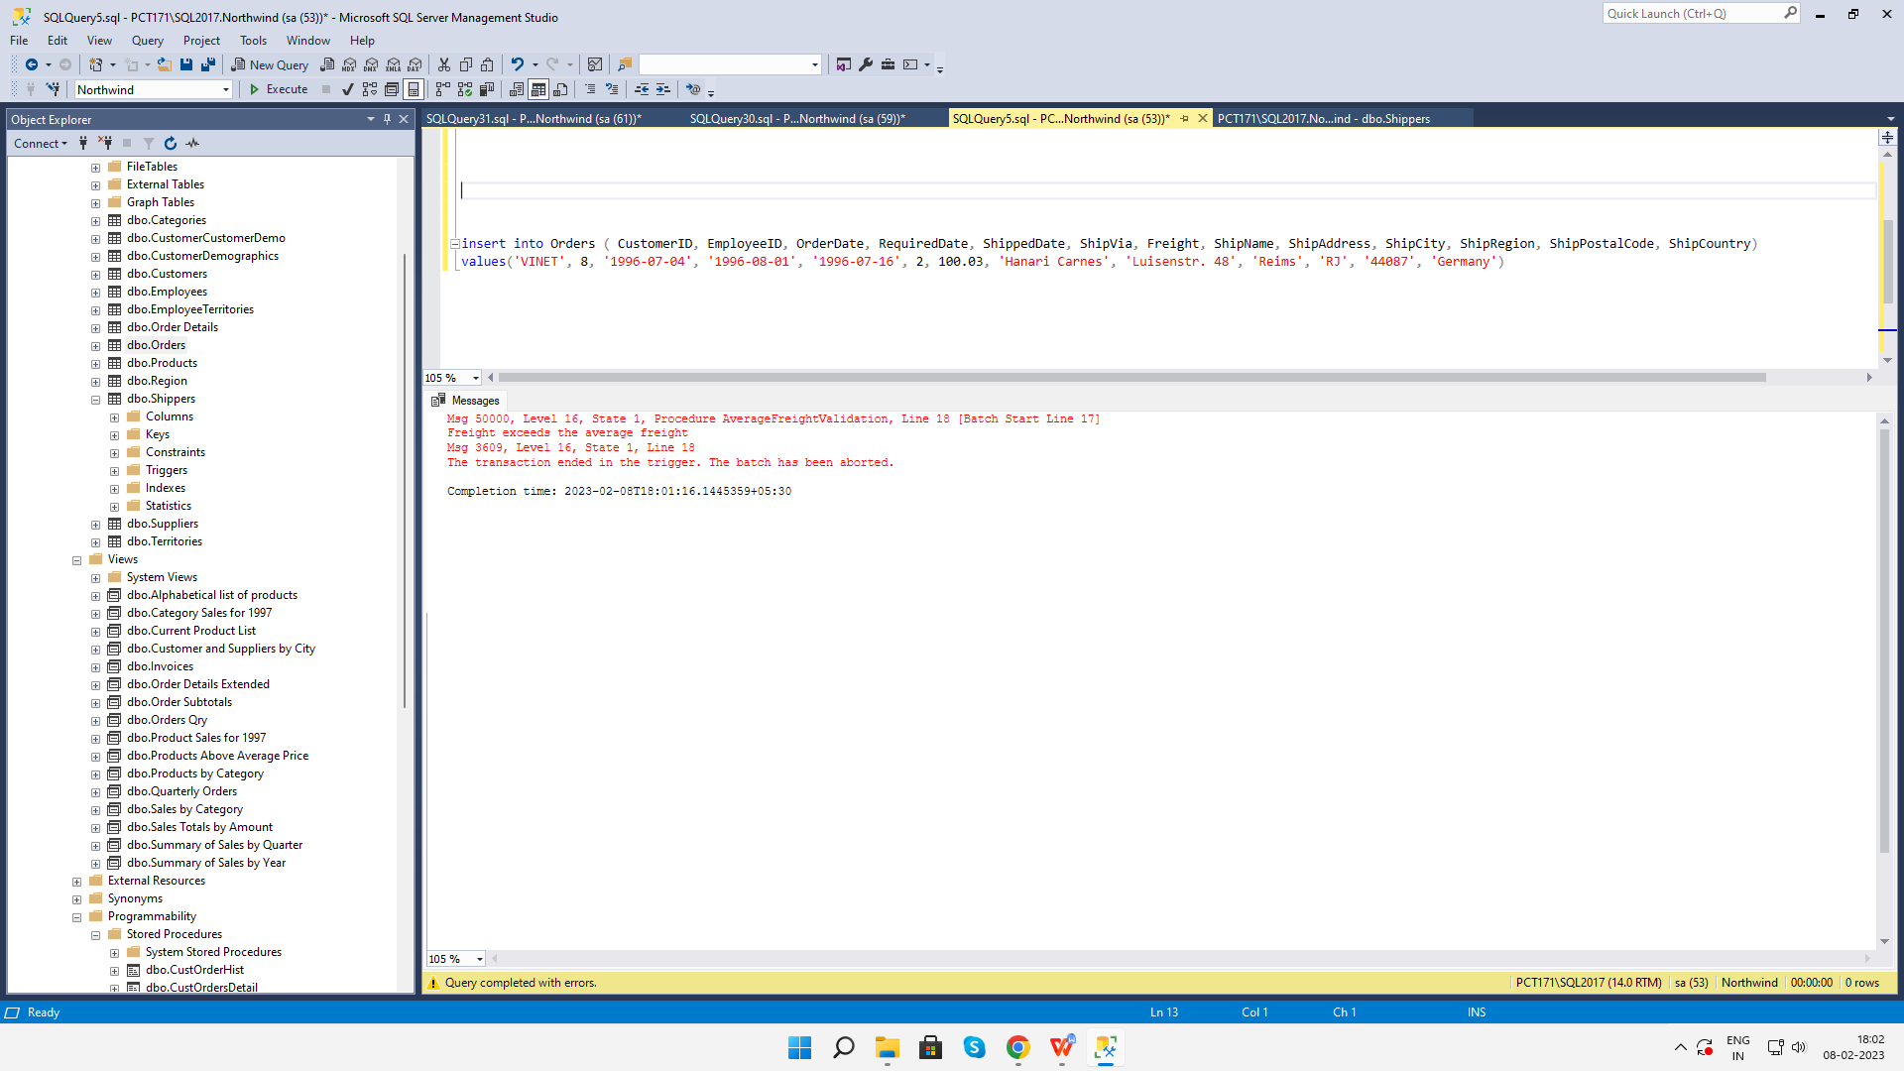

**2. write a SQL query to Create Stored procedure in the Northwind database to retrieve**

**Employee Sales by Country**

alter procedure [dbo].[Employee Sales by Country]

@country nvarchar(15) AS

SELECT Employees.Country, Employees.LastName, Employees.FirstName, Orders.ShippedDate, Orders.OrderID, "Order Subtotals".Subtotal AS SaleAmount

FROM Employees INNER JOIN

(Orders INNER JOIN "Order Subtotals" ON Orders.OrderID = "Order Subtotals".OrderID)

ON Employees.EmployeeID = Orders.EmployeeID

WHERE Orders.ShipCountry = @country

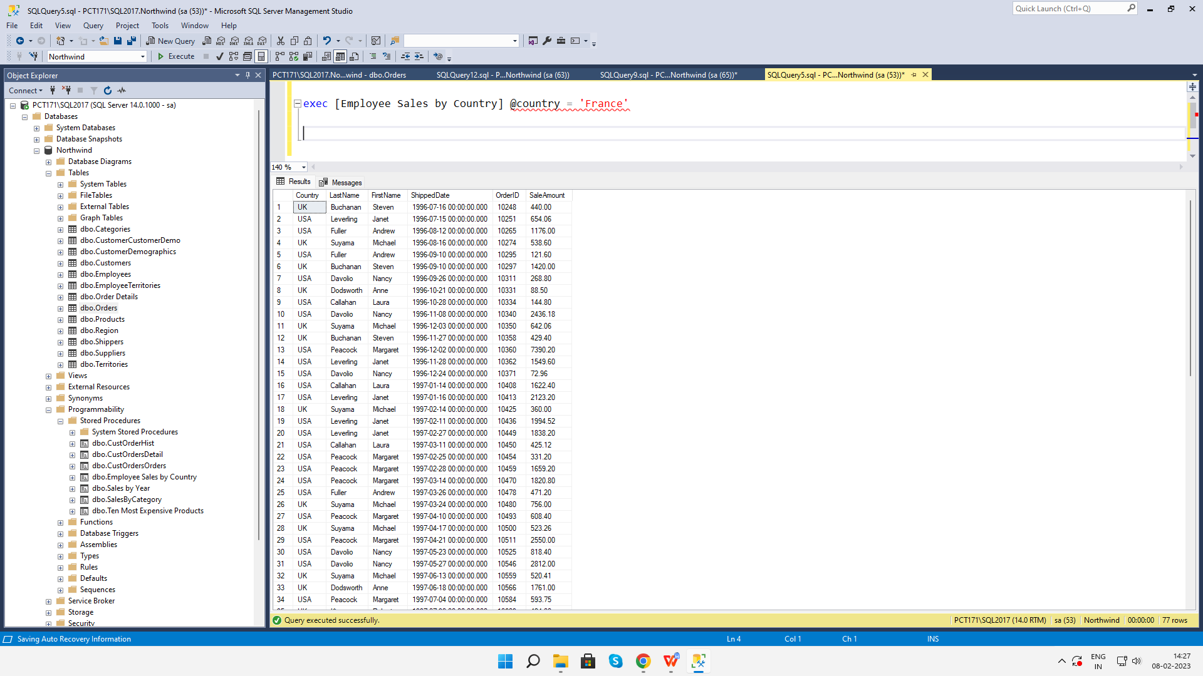

**3. write a SQL query to Create Stored procedure in the Northwind database to retrieve**

**Sales by Year**

ALTER procedure [dbo].[Sales by Year]

@year nvarchar(4) AS

SELECT Orders.ShippedDate, Orders.OrderID, "Order Subtotals".Subtotal, DATENAME(yy,ShippedDate) AS Year

FROM Orders INNER JOIN "Order Subtotals" ON Orders.OrderID = "Order Subtotals".OrderID

WHERE DATENAME(yyyy,Orders.ShippedDate) = @year

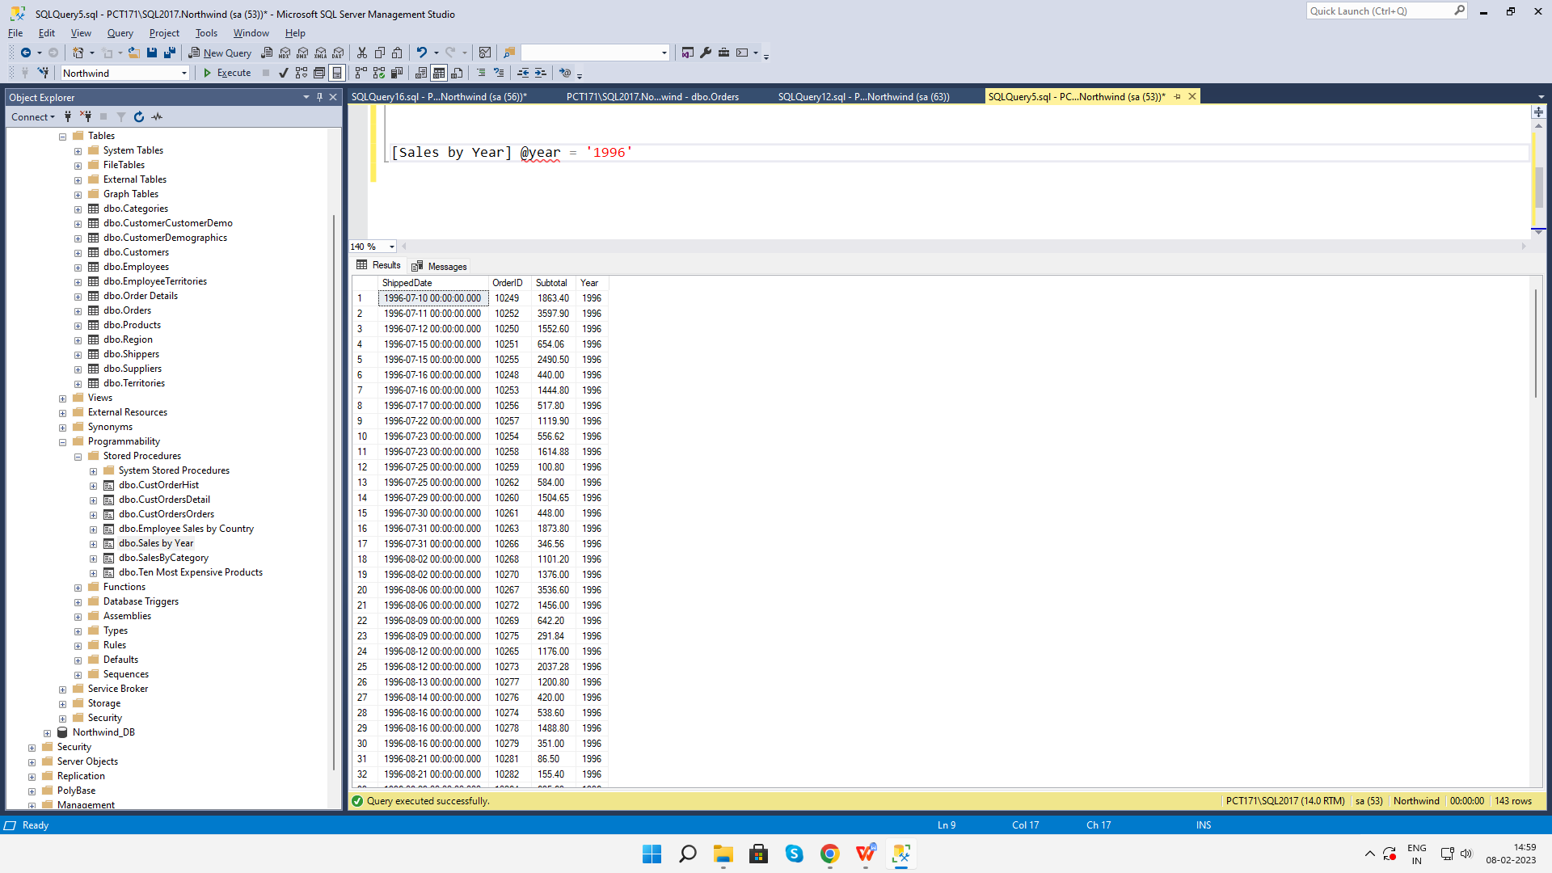

**4. write a SQL query to Create Stored procedure in the Northwind database to retrieve**

**Sales By Category**

USE [Northwind]

GO

/****** Object: StoredProcedure [dbo].[saleswithcategory] Script Date: 08-02-2023 16:03:21 ******/

SET ANSI_NULLS ON

GO

SET QUOTED_IDENTIFIER ON

GO

ALTER PROC [dbo].[saleswithcategory] @category nvarchar(20)

as begin select * from Products P

left join Suppliers S on S.SupplierID=P.SupplierID

right join Categories C on C.CategoryID = P.CategoryID

where C.CategoryName = @category; end

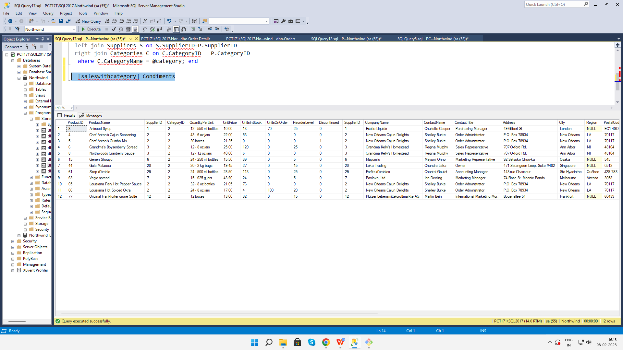

**5. write a SQL query to Create Stored procedure in the Northwind database to retrieve**

**Ten Most Expensive Products**

USE [Northwind]

GO

/****** Object: StoredProcedure [dbo].[Ten Most Expensive Products] Script Date: 08-02-2023 10:21:06 ******/

SET ANSI_NULLS ON

GO

SET QUOTED_IDENTIFIER ON

GO

ALTER procedure [dbo].[Ten Most Expensive Products] AS

SET ROWCOUNT 10

SELECT Products.ProductName AS TenMostExpensiveProducts, Products.UnitPrice

FROM Products

ORDER BY Products.UnitPrice DESC

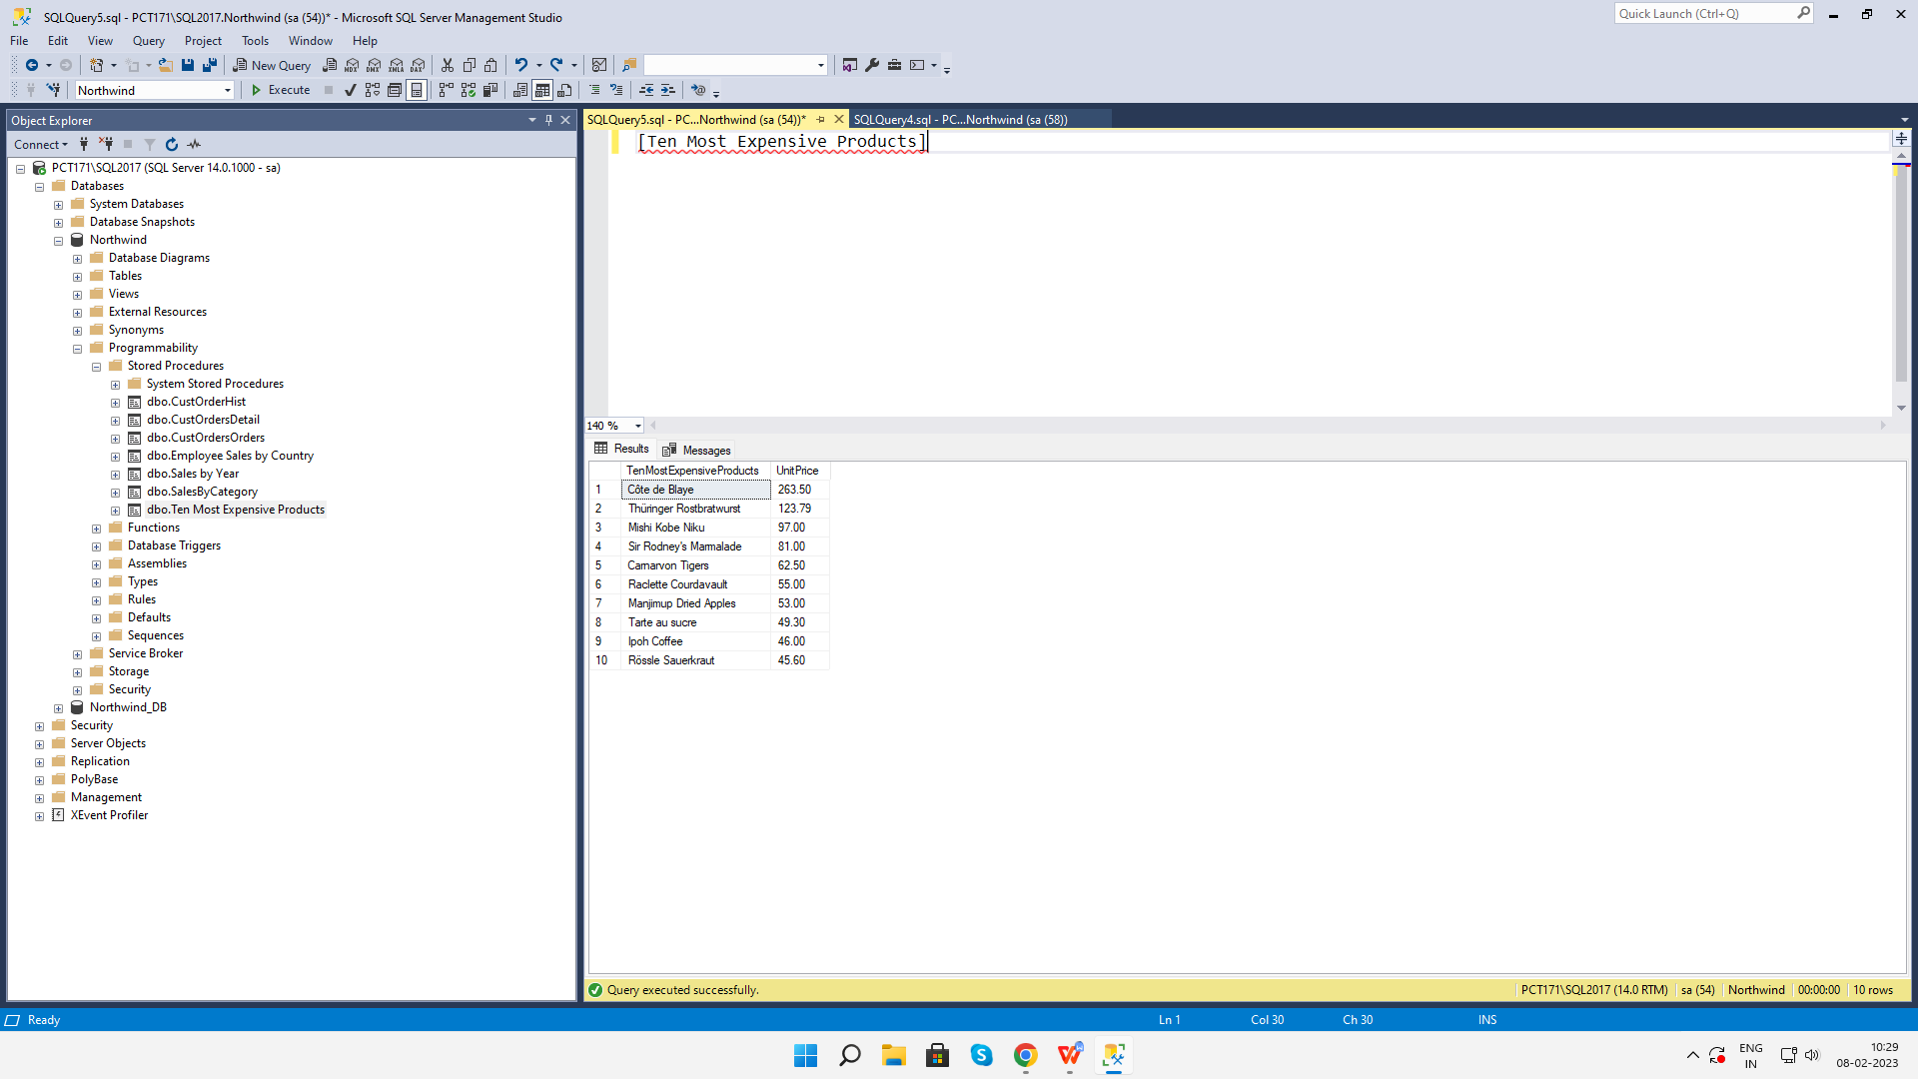

**6. write a SQL query to Create Stored procedure in the Northwind database to insert**

**Customer Order Details**

USE [Northwind]

GO

/****** Object: StoredProcedure [dbo].[insert customer details order] Script Date: 08-02-2023 17:25:22 ******/

SET ANSI_NULLS ON

GO

SET QUOTED_IDENTIFIER ON

GO

ALTER PROCEDURE [dbo].[insert customer details order]

@OrderID INTEGER,

@ProductID INTEGER,

@UnitPrice MONEY,

@Quantity SMALLINT,

@Discount REAL

AS

BEGIN

INSERT INTO [Order Details]

(OrderID,

ProductID,

UnitPrice,

Quantity,

Discount)

VALUES ( @OrderID,

@ProductID,

@UnitPrice,

@Quantity,

@Discount)

END

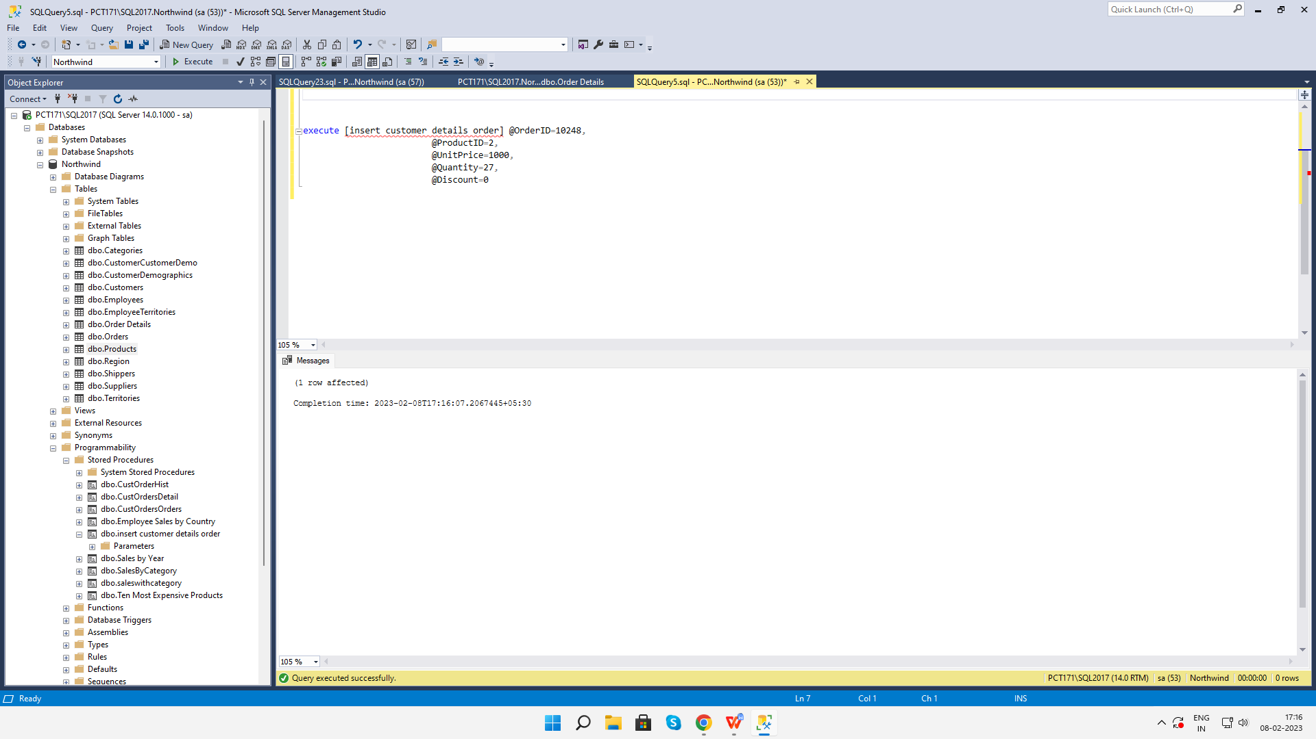

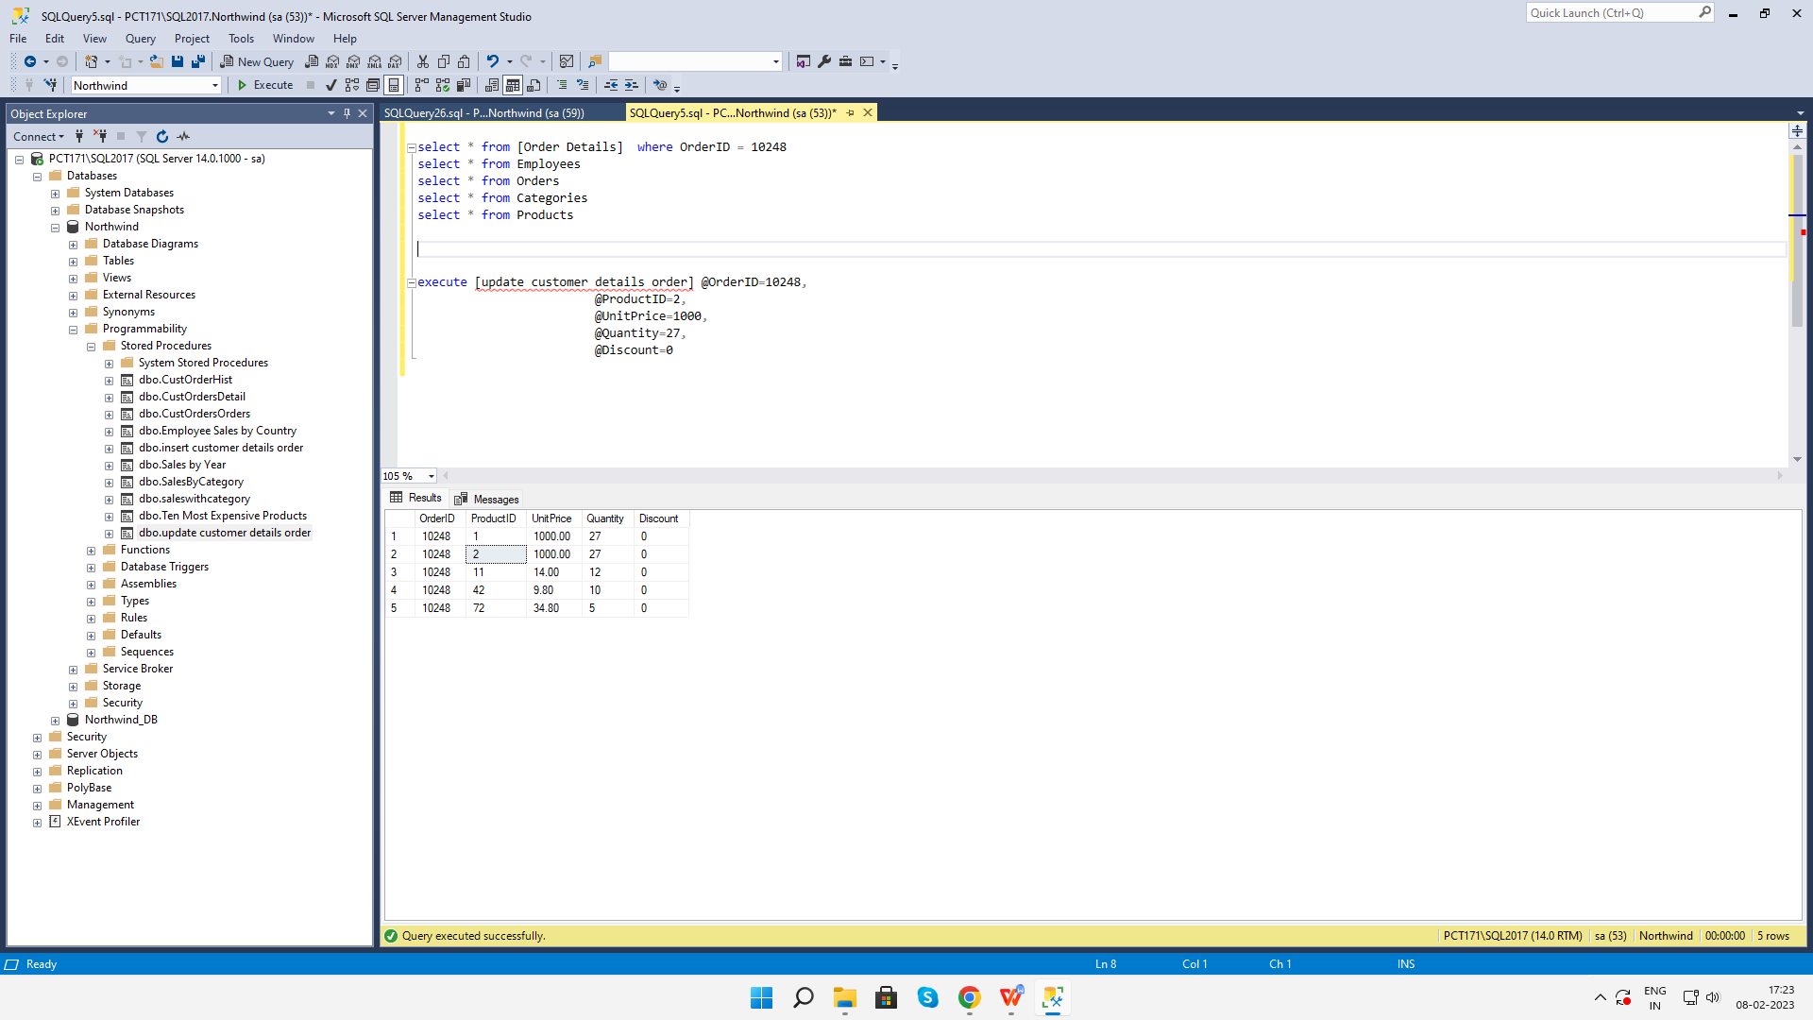

**7. write a SQL query to Create Stored procedure in the Northwind database to update**

**Customer Order Details**

USE [Northwind]

GO

/****** Object: StoredProcedure [dbo].[update customer details order] Script Date: 08-02-2023 17:23:00 ******/

SET ANSI_NULLS ON

GO

SET QUOTED_IDENTIFIER ON

GO

ALTER PROCEDURE [dbo].[update customer details order]

@OrderID INTEGER,

@ProductID INTEGER,

@UnitPrice MONEY,

@Quantity SMALLINT,

@Discount REAL

AS

BEGIN

UPDATE [Order Details]

SET

UnitPrice = @UnitPrice,

Quantity = @Quantity,

Discount = @Discount

WHERE OrderID = @OrderID AND ProductID = @ProductID

END

